TASTEMADE
Spice It Up Your Passover Seder
PART 1

Wednesday, April 6, 2022

Prep Time: 11:00 AM – 11:20 AM Pacific Time (2:00 PM – 2:20 ET)
The Cooking Begins: 11:20 AM - 12:40 PM Pacific Time (2:20 PM – 3:40 PM ET)

Hi! I’m Deb and I am so excited to be doing a Spice It Up with Deb Cooking Class with you! This document includes: your Zoom link, Shopping List, & Recipes. If you plan to cook with me, you will want to have your items out on the counter. It is recommended that you cut the following items in advance: onions, mushrooms and apples. Having prep done in advance will help ensure you stay in time during the cooking process. If you would like to purchase spices from SPICE + LEAF, they are available on Amazon prime. See shopping list for details. If you have questions about the recipes or want to know how to adjust the recipes to meet your dietary need, just text or call me
at 858 967-1364. Debbie

IMPORTANT NOTES:
- I will be demonstrating how to make the Karpas Vegetable Bouquet, but you do not need to do it with me. You are better off just watching me and then doing it on your own for Passover.
- Bonus Recipe Included: Passover Pesto Spread with Sun Dried Tomatoes
- Menu items that you can freeze: Sephardic Haroset, Mushroom Pate, Almond Cake.

Join Zoom Meeting
https://us02web.zoom.us/j/82553672196?pwd=SE53ZWVtamxHNVdYNW1zS2ZhQmZoUT09

Meeting ID: 825 5367 2196
Passcode: 592213

MENU
Karpas Vegetable Bouquet (Vegetable Crudité) – Demonstration Only
Haroset Two Ways: Ashkenazi & Sephardic
Spiced Matzah Crackers
Mushroom Pate (AKA Mock Chopped Liver)
Passover Almond Cake
Bonus Recipe Included: Passover Pesto Spread with Sun Dried Tomatoes – If there is time, I will demo it.

This is your prep document to get all of your fixings ready for our cooking class.
Use this sheet as your check off list.

SHOPPING LIST
Produce / Refrigerated Items

2 Red Gala Apples
1 large package of mushrooms, sliced
1 medium onion, chopped
Margarine (non-dairy and Kosher for Passover if that is your practice or you can use butter)
Eggs

Kitchen items you will need:
1 Cutting board
1 Knife
1 Large sauté pan (mushrooms & onions)
Measuring cups & measuring spoons
Basting brush
1 Wooden spoon
1 Large bowls
3 Medium bowls
Forks & Spoons
Food processor (mushroom pate, Sephardic haroset)
1 - 2 Baking sheet or pan (matzah crackers)
Parchment paper (matzah crackers, almond cake)
Baking dish or pan (8x8 or 9x9) or a tart pan

Pantry Items:
SPICE + LEAF Authentic Za’atar; available on Amazon
SPICE + LEAF Sumac; available on Amazon
SPICE + LEAF Essential Oatmeal Blend; available on Amazon
1 Box of Matzah (my favorite is Streits)
16 oz bag of raw walnuts
Sliced raw almonds, small bag
Slivered almonds
Olive oil
Sea salt
Paprika
Garlic powder
Ground cinnamon
Ground ginger
Honey
20 Pitted dates
Raisins
Sugar
Almond extract
Vanilla extract
Almond flour

Protein: N/A

Dairy: N/A

Specialty Items:
Manischewitz sweet red wine
Red or White wine, NOT sweet

Optional Items:
SPICE + LEAF Galili Olive Oil

See Next Page for more details!

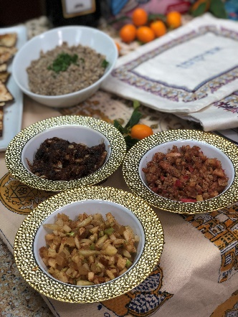

DEB’S FAVORITE HAROSET RECIPES

Ashkenazi Haroset Adapted from Shofar Magazine ©1987

This Haroest recipe is a sure thing! Simple and pure for Ashkenazi Jews who stick to their traditional roots of using apples and nuts. You can definitely play around with the recipes and add more cinnamon or honey or wine to your liking.

(Serves 4 - 6)
2 Red Gala Apples, chopped, keep skin on
½ heaping cup shelled walnuts, chopped (Can add more if you would like)
1 tsp. cinnamon
3 Tbsp. sweet red wine
3 -5 Tbsp. honey
Combine all ingredients and mix well.

Sephardic Haroset Adapted from Shofar Magazine ©1987

I have been using this Sephardic Haroset since the early 1990’s. Guests absolutely love this recipe, and it is fun to bring in Sephardic traditions to the Passover Seder. If you want your Haroset to be even spicier keep adding that ginger, it will add a nice kick to it and help cut through the sweetness!

Serves (4–6)
20 pitted dates, chopped finely (Dates can be made into a minced paste by putting into a food processor.)
1/2 cup raisins (Can add more if you would like.)
1/4 cup slivered almonds (Can add more if you would like.)
2 tsp. SPICE + LEAF Essential Oatmeal Blend (available on Amazon)
Or substitute with
1 + tsp. ginger
1 + tsp. cinnamon
3-5 Tbsp. sweet red wine
3-5 Tbsp. honey

Mix well until it has a smooth – paste like texture.

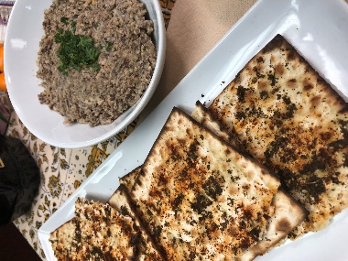

MUSHROOM PATE WITH
SEASONED MATZAH CRACKERS
By Debbie Kornberg
(Serves 4–6)
Ingredients:
2 TBSP. olive oil
1 large package of mushrooms, sliced
1 onion, chopped
2 TBSP. red or white wine, not sweet
1 cup walnuts, chopped finely
Salt to taste

Instructions:
Heat olive oil in sauté pan. Add mushrooms and onions and sauté on medium high heat until cooked all the way down. Once mushrooms and onions are fully cooked and have turned a golden brown, turn up the heat to high for a minute. Then add wine and stir around mushrooms and onions. You will notice that all of the good stuff on the bottom of the pan will be released. Be sure to mix it into everything. (That’s the good stuff!) Place walnuts in food process until very finely chopped into almost a powder. Place in a bowl and set aside. Drain mushrooms and onions of any excess juice mince in a food processor. Add mushrooms and onions to finely chopped walnuts and mix well together. Add Salt to taste. Serve with Matzah crackers.

Spiced Matzah Crackers
By Debbie Kornberg
(Serves 4 -6)
4-6 Tablespoons SPICE + LEAF Premium Galili Olive Oil
4 pieces of matzah
1 Tbsp. SPICE + LEAF Sumac
1 Tbsp. SPICE + LEAF Authentic Za’atar (or can substitute with Oregano)
½ tsp. Paprika
½ tsp. Garlic powder
½ tsp. Sea salt

Cooking Instructions for Matzah Crackers:
Preheat oven to 375 degrees. Using a small bowl, blend all the spices together. Place parchment paper on a baking sheet, place matzah on top. Baste matzah with olive oil generously. Sprinkle spice blend on top of matzah and bake at 375 degrees for 5 -7 minutes until crispy. Let cool and break each matzah into four pieces.

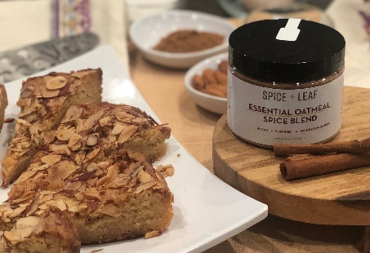

PASSOVER ALMOND CAKE
(Gluten-Free)

Inspired by Marlene Sorosky Grey’s almond cake recipe, this recipe includes spices, of course, and is perfect to make into a gluten-free, Passover cake. Almond flour is the perfect replacement and tastes great! It can be also substituted with other gluten-free flours but do not recommend quinoa flour or coconut flour. (Trust me, I tested it!) This is a quick and easy cake that preps in less than 15 minutes. The batter is stirred in one bowl with just a fork and tastes delicious! When it is not Passover, feel free to use regular flour.

Ingredients:
1 1/2 cups + 2 tsp. sugar
3/4 cup (1 1/2 sticks) Kosher for Passover margarine, parve, melted
2 eggs, large
2 tsp. almond extract
1 tsp. vanilla extract
1/2 tsp. + 1/4 tsp. SPICE + LEAF Essential Oatmeal Blend
Pinch salt
1 1/2 cups almond flour
3/4 cup sliced almonds

Instructions:
- Preheat oven to 350°F. Using a 9-inch cake pan, grease or line with parchment paper.

- In a large bowl, stir together 1.5 cups sugar and butter until blended. Stir in eggs, one at a time, mixing well. Stir in almond and vanilla extracts and salt. Stir in Essential Oatmeal blend, almond flour until blended. Pour batter into greased (or parchment lined) pan.

- Sprinkle almonds, 2 teaspoons sugar, and 1/4 tsp. Oatmeal Spice Blend over the top.

- Bake for about 40 minutes or until lightly golden. The cake is VERY moist so it will not test clean.
It should be toasty brown on top. Cake may be refrigerated up to 2 days or frozen.

Serve warm, chilled or at room temperature.

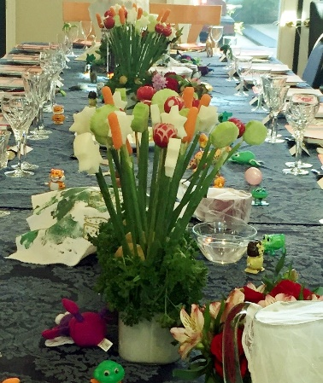

Passover Vegetable Bouquet

By Debbie Kornberg

This is a great way to keep the guests at your table happy during the Passover Seder. Once the blessing for “Karpas” has been said, technically any vegetable that grows from the ground may be eaten. Why should we be only be allowed to eat one little bite of parley or potato? There are many vegetables that are “borei peri ha’adama”. Below are some vegetables that you can choose from to make your own vegetable bouquet for Passover. These will also make great centerpieces for your table.

Suggested Ingredients:

Pick the vegetables you like

1 Bunch radishes
3 - 5 Bunches of parsley
1 Small bag of baby potatoes
1 Bag of baby carrots
3 Bunches green onions
Cauliflower florets
Broccoli florets
1 Cucumber, sliced into thick rounds
1 Stalk of celery, with tops
1 Jicama
1 Bunch asparagus spears, blanched
1 – 2 Packages of thin bamboo skewers
1 - 2 Baskets or vases,
1 - 3 Pieces of foam (depending on size) to place on the bottom of the basket – this is what you will use to hold the bamboo skewers.
And of course - salt water for dipping

Vegetable Preparation and Instructions:
Radishes - Cut the ends off each radish and carve if desired into pedals. Slice half way down on four sides to make petals, leaving the biggest part intact in the center. Soak in ice water, this will help open up the “raddish petals”.

Carrots - Make carrot tulips by slicing toward the pointed end of the carrot with the tip if a sharp paring knife; do not cut through. Form two more petals around the carrot. Angle knife tip to separate tulip from the rest of the carrot. Place in ice water, this will help open up the “carrot petals”.

Jicama - Slice jicama into medium thick slices. Use a small Jewish star cookie cutter and cut out Jewish star shaped jicama. Soak in ice water to keep fresh.
Asparagus - To blanch asparagus, steam cook for only 1.5 minutes and then put into ice water to stop the cooking process. Set aside in a bowl.
Cucumbers – Slice cucumbers; can cut on an angle to look a little fancier. Set aside in a bowl of ice water.
Celery – slice celery leaving enough of a base that a bamboo skewer will be able to poke through. Soak in ice water.
Cauliflower and Broccoli – cut or break into florets. Set aside in a bowl.
Potatoes – Boil potatoes until fully cooked. Slice in halves or quarters. Set aside in a bowl.
Parsley – Cut off about 3/4 of the stem. Set aside in a bowl.
Green Onions – Cut off white ends so the green onion portion is hallow. Set aside.
Basket – Place foam pieces into basket so that the majority of the basket is filled with the Styrofoam.

Final Steps:
Step 1: Place all of the parsley on the bottom of the basket so it covered the base and fills in the cracks.
Step 2: Inserting all of the skewers into one hallowed green onions.
Step 3: Place each prepped vegetable onto a skewer (covered with green onion)
Step 4: Place each completed skewer into the bouquet base. Repeat using all of your vegetables keeping in mind the balance of shapes and colors of the vegetables.
Step 5: Once you have placed vegetable skewers in basket, place potatoes at the base of the basket and lay on top of parley. Think of them as the “rocks” to your garden.

BONUS RECIPE: Passover Pesto Spread
with Sun Dried Tomatoes
By Debbie Kornberg
Ingredients:
2 Garlic cloves, minced
1 cup Fresh basil
1/2 cup Fresh Italian leaf parsley
1/3 cup Olive oil
1/3 cup Walnuts
1/4 Pine nuts
1/4 Sun dried tomatoes
Optional: 1/4 cup Parmesan cheese, grated

Instructions:
Using a food processor, mince garlic cloves. Then add all the remaining ingredients and chop in food processor until it has a spread like texture. Ready to serve! Excellent with my Matzah Crackers recipe!

